1. EXECUTIVE SUMMARY
This report documents a successful Proof of Concept (PoC) demonstrating "In-Memory Patching" (live memory data poisoning) within a running process without altering the application's binary or control flow. By directly manipulating physical RAM blocks, the value of a protected variable was corrupted without the runtime's awareness. This technique illustrates the core mechanics behind sophisticated fileless malware and Advanced Persistent Threats (APTs) used to evade EDR (Endpoint Detection and Response) and antivirus systems.

2. TECHNICAL ANALYSIS & METHODOLOGY
In the CPython runtime, string objects are not stored as raw characters immediately at their initial memory address. Instead, the 64-bit CPython architecture prepends internal object management data (metadata) before the actual data payload.
This structures header is called PyASCIIObject and occupies exactly 48 bytes of memory:
- Reference Count (8 Bytes): Tracks how many variables point to this object.
- Type Pointer (8 Bytes): Defines the object type (string, int, etc.).
- Metadata & State (32 Bytes): Stores length, hash values, and status flags.
Consequently, to reach the exact byte where the actual characters (Data Payload) begin, a 48-byte offset must be added to the object's base address:
$$\text{Target Memory Address} = \text{id(message)} + 48$$

3. PROOF OF CONCEPT (Step-by-Step Exploitation)

Step 1: Initializing the Legitimate Variable in RAM

A benign string variable was declared to simulate a legitimate application storing sensitive data in memory. The physical memory address (pointer) was captured using the id() function
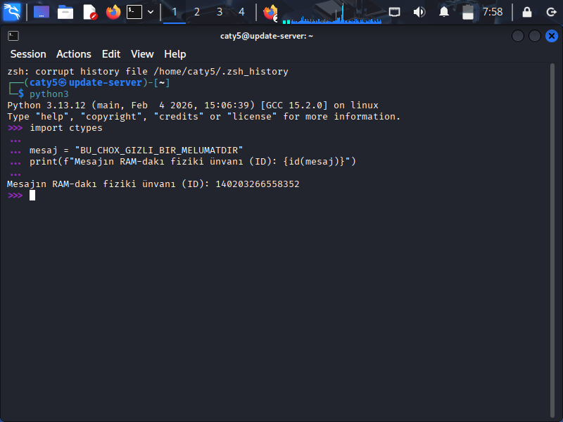
:

Step 2: Direct Memory Injection via Pointer Manipulation
Bypassing the application's normal assignment boundaries, the ctypes.memmove function was leveraged to perform a raw memory overwrite at the calculated address (base_address + 48). Because the original string was 28 bytes long, the malicious payload was designed to be exactly 28 bytes to prevent memory corruption (Segmentation Fault) and keep the application stable:

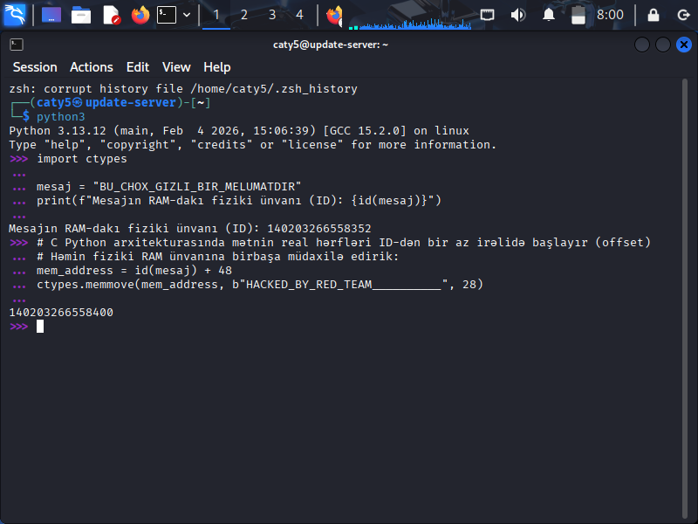

Step 3: Verifying the Exploitation (Data Corruption)
When the application referenced the variable again, it followed the original pointer to RAM. Because the underlying memory cell was overwritten inline, the program printed the injected malicious payload instead of the original text:
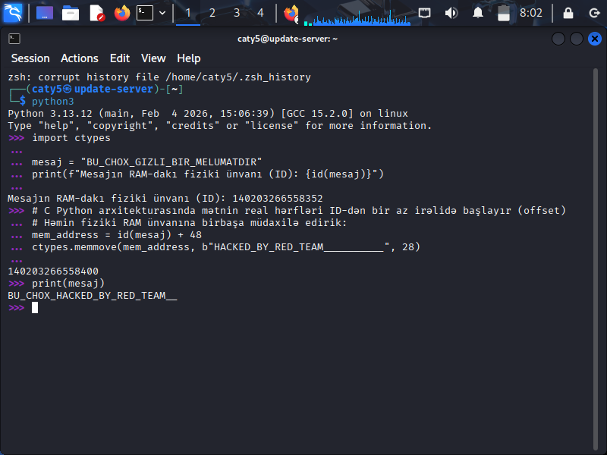

4. BLUE TEAM MITIGATION & CONCLUSION
This PoC confirms that attackers can manipulate runtime data and alter application behavior entirely within memory, leaving zero traces on the disk for traditional signature-based scanners.
Remediation & Defense Strategies:
- Memory Inspection: EDR solutions must actively monitor process memory layouts (/proc/[PID]/maps) for anomalous write patterns and restrict unauthorized low-level memory cloning or movement (memmove/memcpy) inside high-risk runtime environments.
- Hardening Runtimes: In production environments, access to low-level Foreign Function Interfaces (FFI) and system-level libraries (such as Python's ctypes or Node.js ffi) should be strictly controlled or completely disabled unless explicitly necessary.

